SIMATS ENGINEERING
ASSESSMENT TOOL 2
COURSE NAME: Computer Vision with OpenCV COURSE CODE: DSA0202
COURSE OUTCOME COVERED

CO2: Apply image processing and feature extraction techniques, including edge detection, motion estimation, and optical flow, for analysing images.. (BL3)
Assessment Tool Weightage: 30%
QUESTIONS: 3 Total Marks:30 Annexure A
Scenario-Based
Code of Conduct:
I N.JOE JERISH (192524374) certify that this submission is my original work and that I have adhered to the guidelines specified for this assessment.
I understand that any violation of academic integrity rules will result in disciplinary
action.

Signature of the student:
RUBRICS FOR CALCULATION
 |  |  | Scenario based assessment
Criteria | Weight  age  (%) | Level 4 (Exemplary) | Level 3  (Proficient) | Level 2  (Developing) | Level 1  (Beginning) | Marks
Understa  nding of  Scenario | 20% | Demonstrates clear and complete understanding of the scenario and  context | Shows good  understanding with minor gaps | Partial  understanding;  misses key aspects | Misinterprets or fails to understand the scenario
Identifica tion of  Key  Issues | 20% | Accurately identifies all relevant issues and  factors involved | Identifies most key issues with minor omissions | Identifies limited issues; some  irrelevant points | Unable to identify key issues
Applicati on of  Concepts | 25% | Applies appropriate  concepts effectively to address the scenario | Applies  concepts with  minor errors | Limited or  partially correct application | Unable to apply relevant concepts
Decision Making | 20% | Makes well-reasoned, logical decisions with strong rationale | Makes  reasonable  decisions with some  justification | Makes weak  decisions with  limited  justification | No clear decisions made or rationale provided
Clarity of Response | 15% | Response is clear,  structured, and logically presented | Generally clear with minor  issues | Somewhat unclear or poorly  structured | Disorganized and difficult to  understand

Annexure A
Scenario-Based
1. Crack Detection on Concrete Surfaces Using Drone Images
Scenario: A civil inspection team is developing a computer vision system to detect thin cracks on concrete bridges and building surfaces. Images are captured using a drone under outdoor conditions. Due to changing sunlight, shadows, and camera vibration, the raw images contain uneven illumination, low contrast, and Gaussian noise.
Questions:
A. Propose a suitable image preprocessing pipeline to prepare the drone images for crack detection. Your answer should include methods for illumination correction, noise reduction, contrast enhancement, and image normalization. Justify the need for each step.
B. Select an appropriate edge detection technique for identifying thin surface cracks. Compare it with at least one other edge detection method and explain why your selected technique is more suitable for detecting fine cracks.
C. After edge detection, some crack segments appear broken or disconnected. Suggest a suitable post-processing technique to connect the crack regions and improve the final detection output.
2. Human Motion Tracking in a Security Camera Video
Scenario: A security camera is installed in a hallway to monitor people moving in different directions. The system must estimate the motion of each person across video frames for tracking and activity analysis. The hallway contains plain walls, smooth floors, and occasional shadows.
Questions:
A. Explain how the Lucas-Kanade optical flow method can be used to estimate the motion of people between consecutive video frames.
B. Discuss how the aperture effect can create errors in motion estimation, especially on uniform regions such as plain walls, floors, and clothing surfaces.
C. If a person suddenly changes speed or direction, describe how the optical flow vectors will be affected. Suggest a method to improve tracking accuracy in such situations.
3. Vehicle Tracking at a Traffic Junction Using Video Frames
Scenario: A smart traffic monitoring system uses CCTV footage to track vehicles at a busy road junction. Vehicles move at different speeds, some stop suddenly at signals, and others turn left or right. The video also contains shadows, reflections, and partial occlusion when vehicles overlap.
Questions:
A. Explain how optical flow can be used to estimate the direction and speed of moving vehicles in the video sequence.
B. Identify two challenges that may affect accurate motion estimation in this scenario, such as occlusion, shadows, sudden braking, or camera vibration. Explain how each challenge affects the optical flow result.
C. Suggest a suitable improvement method to make vehicle tracking more reliable when vehicles overlap or change direction suddenly.

Question 1 — Crack Detection on Concrete Surfaces Using Drone Images

A. Preprocessing Pipeline
A four-stage pipeline is proposed, applied in the order below so that each stage produces a cleaner input for the next:
1. Illumination correction — CLAHE (Contrast Limited Adaptive Histogram Equalization) or homomorphic filtering. Drone shots taken outdoors have strong lighting gradients from the sun and shadows; this step normalises brightness locally so that a real crack is not hidden in a dark shadow region and a shadow edge is not mistaken for a crack.
2. Noise reduction — a bilateral filter (or Gaussian filter as a simpler alternative). A bilateral filter smooths flat concrete texture while preserving crack edges, which is important because a plain Gaussian blur would blur out the very thin crack lines it is trying to help detect. This removes the Gaussian noise introduced by drone vibration and the camera sensor.
3. Contrast enhancement — histogram stretching / equalization performed after denoising. It widens the intensity gap between the (usually darker) crack pixels and the surrounding concrete, which is essential since cracks are inherently low-contrast against the background.
4. Normalization — pixel intensity scaling (e.g., to a 0–1 or 0–255 standard range) and geometric resizing to a fixed resolution. This keeps downstream thresholds (for edge detection) consistent across images captured at different altitudes, exposures, or times of day.
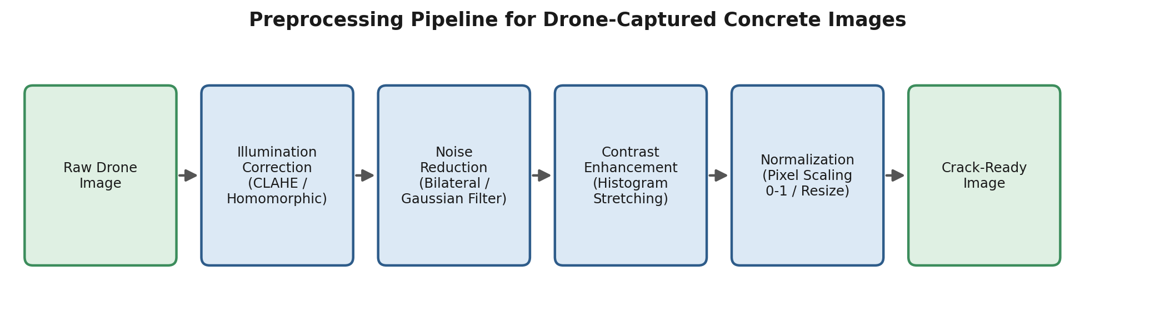
Figure 1. Proposed preprocessing pipeline for drone-captured concrete surface images.

B. Edge Detection Technique
Selected technique: Canny edge detector. Canny is better suited to fine, low-contrast cracks than a plain gradient operator such as Sobel, for three combined reasons: (i) it applies Gaussian smoothing before gradient computation, so it is less reactive to residual sensor noise; (ii) it performs non-maximum suppression, which thins the detected edge to a single-pixel-wide line — critical for hair-line cracks that are only a few pixels wide; and (iii) it uses hysteresis thresholding (two thresholds) so weak-but-connected edge pixels belonging to a real crack are retained while isolated noisy pixels are discarded.
Comparison with Sobel: Sobel only computes a first-order gradient magnitude and needs a single external threshold. Without built-in smoothing or thinning, it produces thicker, blurred edges and is far more sensitive to the Gaussian noise present in the drone images, so a fine crack is rendered as a broken, noisy trail rather than a continuous thin line — exactly what Figure 2 illustrates.
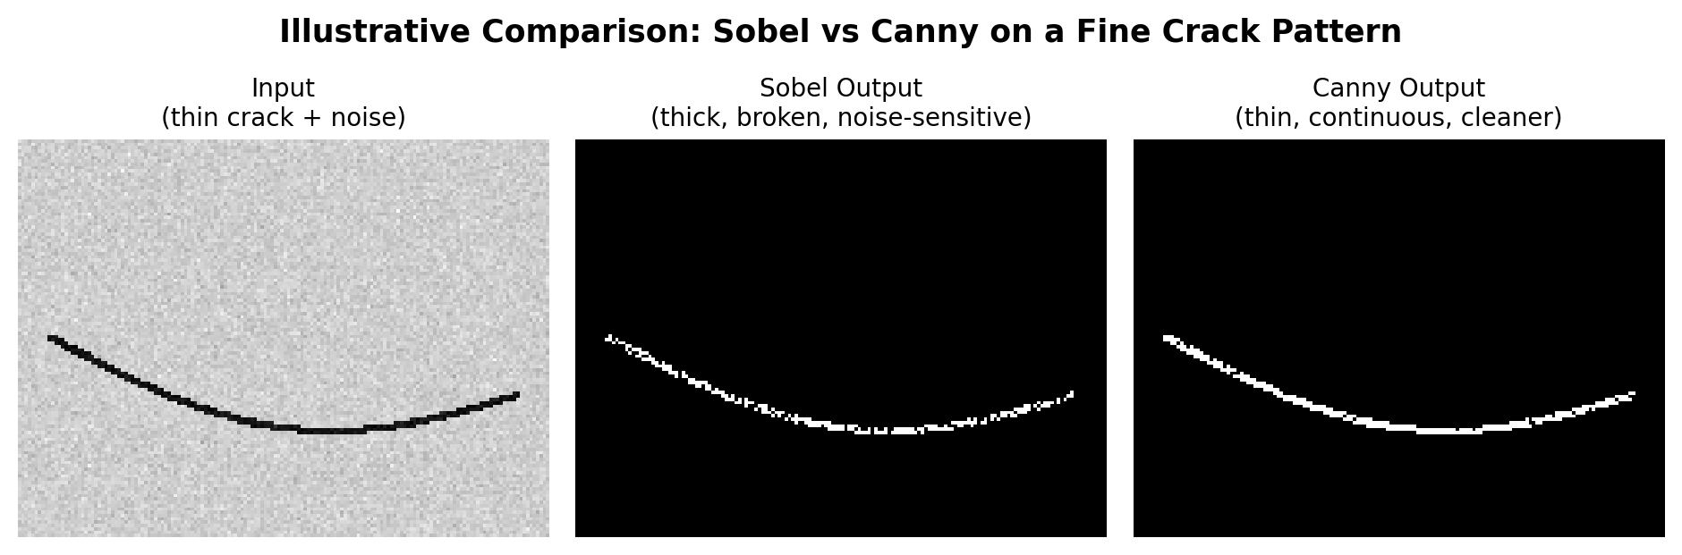
Figure 2. Illustrative comparison of Sobel and Canny outputs on a thin, noisy crack.

C. Post-processing for Broken Crack Segments
Even with Canny, thin cracks can fragment where contrast briefly drops. A suitable fix is:
- Morphological closing (dilation followed by erosion) with a small, elongated structuring element oriented along the local crack direction — this bridges small gaps without thickening the crack excessively.
- Skeletonization after closing, to return the crack to a clean single-pixel-wide line suitable for measuring length and width.
- Endpoint linking — connected-component analysis to find crack-segment endpoints, then joining endpoints that are close together and roughly co-linear (a simplified crack-linking / Hough-transform-assisted approach), so that genuinely separate segments are not merged incorrectly.

Question 2 — Human Motion Tracking in a Security Camera Video

A. Lucas-Kanade Optical Flow for People Tracking
The Lucas-Kanade (LK) method rests on two assumptions: brightness constancy (a point's intensity does not change between consecutive frames) and local spatial coherence (neighbouring pixels move together, i.e. motion is small and roughly constant within a small window).
For a tracked point (typically a corner feature detected via Shi-Tomasi or Harris on the person's silhouette or clothing pattern), LK sets up the optical-flow constraint equation using the spatial gradients (Ix, Iy) and the temporal gradient (It) for every pixel inside a small neighbourhood window around that point. Because one equation per pixel is not enough to solve for the two unknown velocity components (u, v), LK pools the equations from the whole window and solves the resulting over-determined system by least squares, giving a stable per-point velocity estimate. Repeating this for each tracked point across every frame pair builds the trajectory of each person as they move down the hallway.

B. Effect of the Aperture Problem
A hallway's plain walls, smooth floor, and uniform clothing regions have almost no local texture — the intensity gradient is roughly constant in one direction across the whole window. In that situation only the motion component perpendicular to the local edge/gradient can be measured; the component running along the edge is invisible to the local window and stays undetermined. This is the aperture problem, illustrated in Figure 3 (right).
Its practical effect on tracking is that flow vectors on these uniform regions become unreliable or biased toward the perpendicular direction only, causing drift — a tracked point can appear to "slide" along a wall or floor edge even when the person's true motion has a different direction, which degrades trajectory accuracy unless corner-like, textured points are used instead of flat regions.
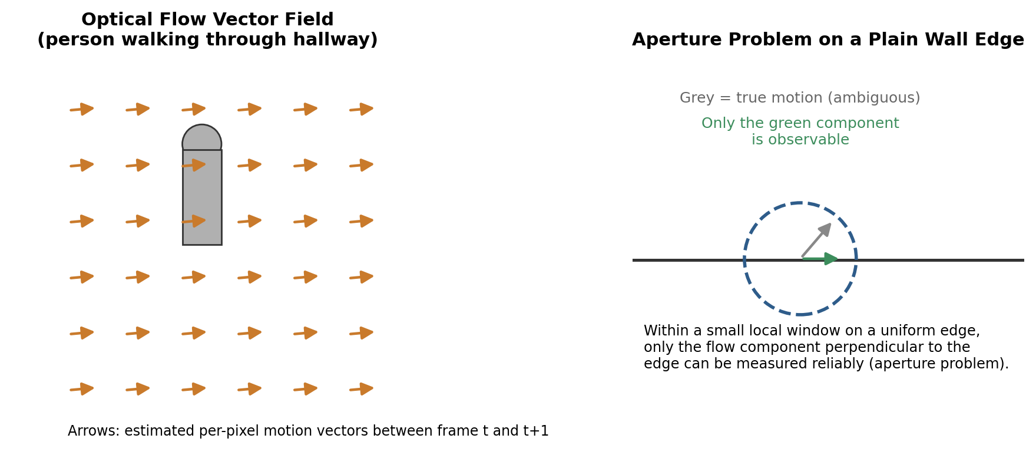
Figure 3. Left: estimated flow vectors for a walking person. Right: the aperture problem on a plain, low-texture edge.

C. Sudden Change in Speed or Direction
Lucas-Kanade's linearisation (the Taylor-series approximation behind the brightness-constancy equation) is only valid for small displacements between frames. If a person suddenly speeds up, stops, or changes direction, the actual displacement can exceed this small-motion assumption, so the computed flow vectors become inaccurate, noisy, or the tracked point is lost/mismatched to a nearby wrong location entirely.
To improve tracking accuracy in such situations:
- Pyramidal (coarse-to-fine) Lucas-Kanade — estimate flow on downsampled versions of the frame first, then refine at full resolution, which allows the method to handle much larger displacements than single-scale LK.
- Motion prediction with a Kalman filter — predict the likely next position from the person's motion history and use optical flow only to refine around that prediction, so a sudden change is anticipated rather than missed.
- Periodic re-detection of feature points — refresh tracked corners every few frames so that a lost or drifted track is quickly replaced rather than compounding error.

Question 3 — Vehicle Tracking at a Traffic Junction Using Video Frames

A. Using Optical Flow for Direction and Speed
Optical flow is computed either densely (e.g., Farneback) across the whole frame or on tracked feature points on each vehicle (KLT / Lucas-Kanade). Each resulting flow vector has a magnitude and an angle: the magnitude, scaled by frame rate and camera calibration, gives the vehicle's speed, while the vector's angle gives its direction of travel through the junction. Aggregating the vectors that fall inside a vehicle's bounding box (rather than trusting a single point) gives a more stable per-vehicle speed and direction estimate frame to frame.

B. Two Key Challenges
1. Occlusion — when one vehicle passes behind or overlaps another, the feature points on the occluded vehicle disappear or merge with the occluder's points. This produces flow vectors that describe the wrong object, and once the vehicles separate again, the tracker can swap identities or lose the trajectory entirely.
2. Shadows and reflections — a moving shadow is not part of the vehicle's rigid body but moves with it, so it generates its own flow vectors that are typically merged into the vehicle's bounding box. This inflates the apparent size of the vehicle and skews the averaged speed/direction estimate; wet-road reflections cause a similar problem by creating flow that does not correspond to any real motion.
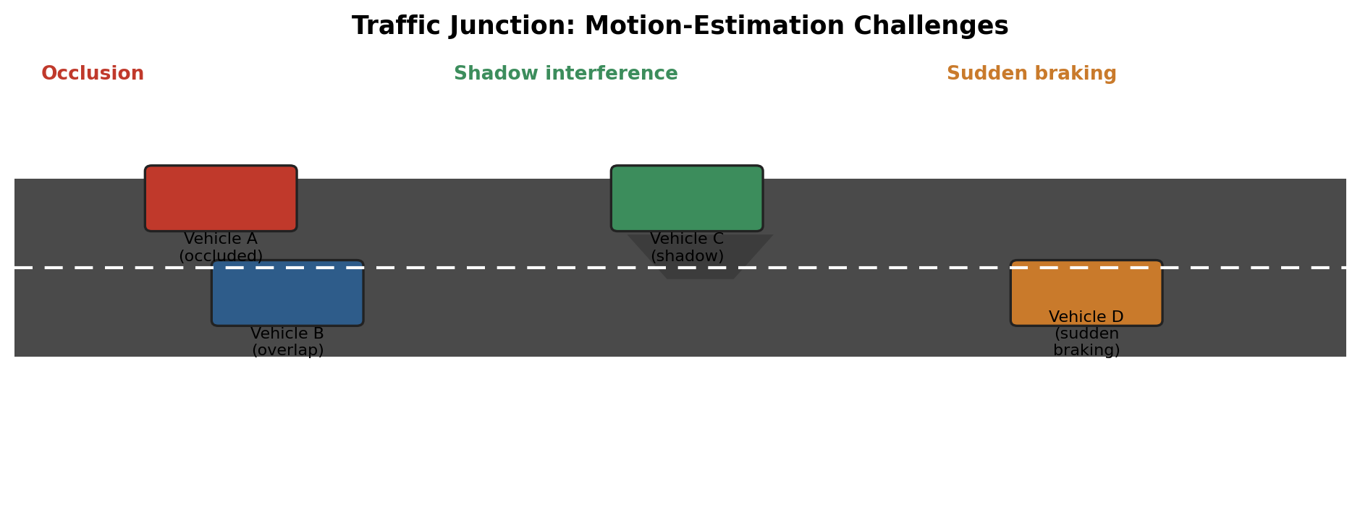
Figure 4. Motion-estimation challenges at a junction: occlusion, shadow interference, and sudden braking.

C. Improvement for Overlap and Sudden Direction Change
A tracking-by-detection approach that combines optical flow with a motion filter is recommended: each vehicle is tracked with a Kalman filter (or particle filter) that predicts its position and velocity every frame, while optical flow / detections provide the measurement update. During occlusion the filter continues to predict the vehicle's position from its motion history, so identity is preserved once it re-emerges; data association across frames can be strengthened with an IOU or appearance-based matching step (the principle used in SORT / DeepSORT trackers). Pairing this with an HSV-based shadow-removal step before flow computation (shadows have similar hue but distinctly lower value/saturation than the vehicle) further prevents shadow pixels from being tracked as if they were part of the vehicle.

